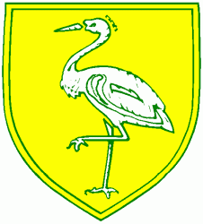
Benwick Primary School
High Street, Benwick, March, Cambs. PE15 0XA

Telephone: 01354 677266 email: office@benwick.cambs.sch.uk

Headteacher: Mrs. J. North, BEd Hons, NPQH www.benwick.cambs.sch.uk
25-May-16

CLASS 2 ONLY - TRIP TO SNETTISHAM PARK FARM

Dear Parents / Carers,

I am hoping to organise a trip to Snettisham Park Farm on Monday 6th June 2016 for the children in Class 2.

The discounted cost of entry to the Park is £173.60 and the cost of the coach is £310. This makes a total of £483 (£17.27 per child). The FOBS usually pay for the coach which keeps the cost down considerably but the FOBS are unable to subsidise any coach trips this term. We are happy to pay £2.27 per child from school funds but we are asking for a contribution of £15 per child. If we do not have enough contributions we will be unable to go ahead with the trip. If you are in receipt of Pupil Premium there may be funds available to help. Please make an appointment to see Mrs North.

Children will need to bring a packed lunch and a drink (no glass bottles or fizzy drinks please). They will also need suitable clothing/footwear according to the weather on the day.

Please could you fill in the slip below and return it to us by Monday 23rd May at the latest.

Yours sincerely,

Miss Garner - Class Teacher

-----------------------------------------------------------------------------------------------------------------------------

CLASS 2 ONLY - TRIP TO SNETTISHAM PARK FARM

ON MONDAY 6th JUNE 2016

Name of child/children…………………………………………………………………………………………………………………….

I enclose contribution of: cash / cheque

Signed…………….……………………………………………………………..……………………..…………

Please print your name clearly…………………………………………………………………………

Please do not fill in this part - For office use only:
Paid cash / cheque no:

Date:

Receipt No: Signed:

