Dogger
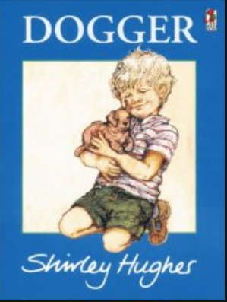

Author and illustrator: Shirley Hughes

Watch at (for example)
https://www.youtube.com/watch?v=jNOYgRf5jes

In this lovely story, a boy loses his precious toy dog.

Something to think about:

- Have you ever lost a toy? Where? How did you feel?
- Bella did a kind thing for her brother. What kind things have you done?

Something to do:

- Draw a picture of your favourite toy. Write labels or a few sentences to describe it.
- Can you make a ‘lost’ poster for Dogger?

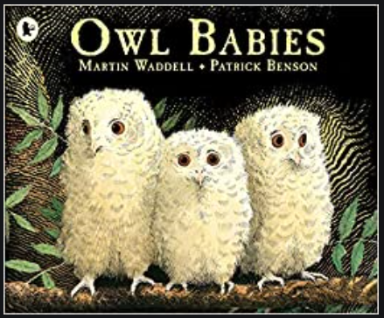
Owl Babies

Author: Martin Waddell
Illustrator: Patrick Benson

Watch at (for example)
https://www.youtube.com/watch?v=TPQRiSTYFHo

In this beautiful book, three little owls wait for their mummy to return.

Something to think about:

- How can we tell what each owl baby is like?
- Can you describe the wood where the owl babies live?

Something to do:

- Retell the story using some of your cuddly toys (they will have fun pretending to be owls!)
- The owls’ mummy left a note explaining where she had gone. Can you write it?

