Owls Topic Homework
Julia Donaldson

Choose one activity to complete each week/fortnight. Record it in your book to share with the class, and bring projects in at the end of each half term – dates on link up. As always, you can explore our topic in any other way you can think of and present it back to the class.

Read a Julia Donaldson book of your choice and write a book review of it  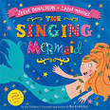 | Make some Gruffalo themed cup cakes. Take a photograph and write the instructions.  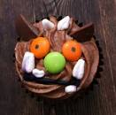 | 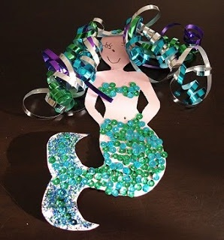  Choose a character from a Julia Donaldson book and create a piece of art to represent that character. | Find out 10 interesting facts about Julia Donaldson and record them as an exciting poster.   | Design a Wanted Poster for the Gruffalo  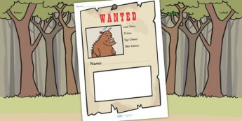
Write another story about the Gruffalo. What adventure does he have this time?  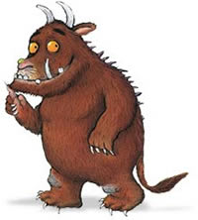 | Make a board game linked to a Julia Donaldson book.  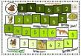 | Design and label your own terrible creature.  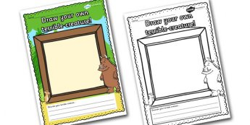 | Write a letter to Julia Donaldson telling her why you liked one of her books.   | Choose one nocturnal animal to research.  