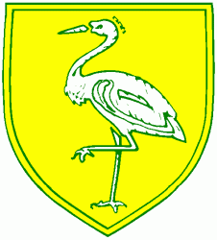
Benwick Primary School
High Street, Benwick, March, Cambs. PE15 0XA

Telephone: 01354 677266 email: office@benwick.cambs.sch.uk

Headteacher: Mrs. J. North, BEd Hons, NPQH www.benwick.cambs.sch.uk
Chair of Governors: Mr. D. Gore
20-Sep-19

Dear Parents/Carers,

As part of our Science topic this term, ‘Living Things and their Habitats’, I would like to take the children out into the village to investigate plant samples. Although there are plants within the school grounds, I feel there will be more variety for the children to explore.

You should be aware that you have already given prior permission for your child to be taken out in the village back at the beginning of the year.

As this is a local trip out, it will be weather dependent. Please ensure that your child attends school with suitable footwear and a coat. Our first trip will be on Tuesday (24/09/19), followed by a second trip after the half term.

If you have any further concerns, please speak to myself or Mrs North.

Yours Sincerely,

Miss Baker

