Benwick Primary School

Head teacher
Application Pack

Contents

- Introduction from the Chair of Governors

- Appointment Process

- Missions Statement and Aims of the School

- Locality Information

- Job Description

- Person Specification

Appended Separately:

Ofsted Report

School Prospectus

Schools Equality & Diversity Policy

Application Form

Introduction from the Chair of Governors

Dear Applicant
Thank you for your interest in the post of Head teacher at Benwick Primary School. I am both sad at saying good bye to our current Head teacher who has been a part of the Benwick School community for many year, but I am also excited at the future and the prospect of a new head teacher.
I have been involved in the Governing Body of Benwick Primary school for many years and am proud to have held the position of chair on and off for 5 years. In my time on the Governing body I have seen many changes within the school, the things I most love to see are the teachers performing well and most importantly the youngsters flourishing and enjoying their learning journey through the school.
Being involved in the recruitment of a new head teacher is one of the biggest responsibilities a governor will ever undertake, the pressure of making the right choice for the good of the school and the children is not to be underestimated.
Within the next few pages I have highlighted all the fantastic aspects of Benwick primary and the community as a whole. Separate downloads include the schools prospectus, Ofsted inspection report and the schools equality and diversity policy. I hope that all of this information will spur you even more in to wanting to join our team. The governing body and school community as a whole are looking for a head teacher with vision, drive and determination to ensure the school is judged good or outstanding at its next inspection and urgently improve the outcomes for all our young people.
I look forward to meeting with you soon and wish you all the very best in the process.
Darren Gore
Chair of the Governing Body.

Appointment Process

Start Date | January 2020
Salary Range | L10 – L16
Closing Date for Applications | Midday on 10th October 2019
Shortlisting | 10th October 2019
Interviews | 15th October 2019  Shortlisted candidates will be sent full details of the process.
School Visits | Please Contact:  Mrs V. Gore  Clerk to the Governing Body  07887605449  clerk@benwick.cambs.sch.uk
Application

You are invited to submit a letter of application along with the application form which you will find as part of this pack. Curriculum Vitae are not accepted. The letter of application should address the attributes identified in the person specification with particular emphasis on how you would use your skills and experience to lead improvement and development of the school.

Completed applications should be submitted to:

EPM Ltd
St Johns House
Ermine Business Park
Huntingdon
Cambridgeshire
PE29 6EP

Or emailed to:

headship@epm.co.uk

Mission Statement and Aims of the School

Our Mission Statement: Together We Can

Aims:
- We value and celebrate confidence in ourselves as individuals, knowing that we can make our own contributions to the world.
- We understand the importance of respecting each other and members of our community and taking the responsibility for our own environment.
- We strive to install a love of lifelong learning.
- Learning will be creative, exciting and fun.
Our Values:
RESPECT- I shall listen when other people are talking, I can use appropriate language. I can be polite.
RESPONSIBILTY - I can work on my own/find my own equipment. I can make good decisions. I can do my work and not be distracted by the people around me.
HONESTY- I can do the right thing. I can always tell the truth. I can admit to doing something wrong.
RESILIENCE- I can always make a good effort. I can achieve. I can never say can't unless I have tried my best.
COMMUNITY- I can encourage others. I can make people happy. I can be helpful.

Locality information
Benwick is a thriving, expending Fenland village in Northern Cambridgeshire. We are located between the historic towns of Ramsey, March, Chatteris and Whittlesey, all of which are approximately seven miles away. We are also within easy commuting distance of Peterborough, Wisbech and Huntingdon, as well as numerous small villages.
Although a quiet village, Benwick is close to several major roads: the A1(M), A14 and A47 are all within easy reach.
The cities of Peterborough and Cambridge are within twenty-five miles and offer a great range of shops, cultural centres and amenities.
By rail, London Kings Cross is only an hour’s journey from Peterborough or Huntingdon.

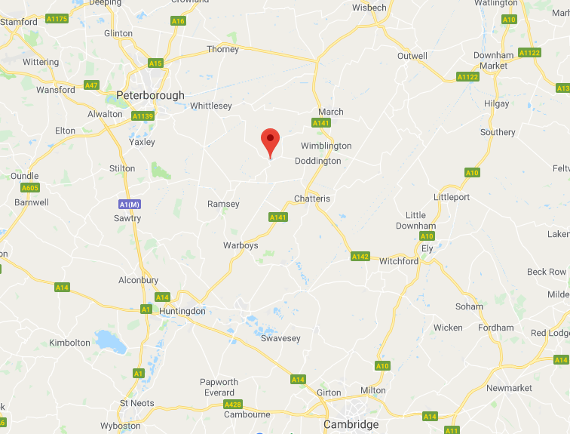

Job description
Core purpose of the Head Teacher
The core purpose of the Head Teacher is to provide professional leadership and management for the school. This will promote a secure foundation from which to achieve high standards in all areas of the school’s work.
To gain success the Head Teacher will:
- Effectively manage teaching and learning
- Nurture the ethos of educating the whole child
- Promote excellence, equality and high expectation for all pupils
- Provide vision, leadership and direction
- Evaluate school performance and identify priorities for continuous improvement
- Deploy resources to achieve the school’s aims
- Carry out day-to-day management, organisation and administration
- Secure the commitment of the wider community
- Create a safe and productive learning environment which is engaging and fulfilling for all pupils
- Work effectively with the schools Governing Body

Leading learning and teaching
Responsibility for raising the quality of teaching and learning and for pupils’ achievements within a successful learning culture.
The Head Teacher will:
- Demonstrate personal enthusiasm for and commitment to the learning process
- Demonstrate the principles and practice of effective teaching and learning
- Access, analyse and interpret relevant information
- Initiate and support research and debate about the effective learning and teaching and develop relevant strategies for performance improvement
- Acknowledge excellence and challenge poor performance across the school

Shaping the future
Working with the Governing Body and others to create a shared vision and strategic plan which inspires and motivates pupils, staff and other members of the school community and to develop the ethos of the school linked to its core aims and values.
The Head Teacher will:
- Think strategically, build and communicate a coherent vision in a range of compelling ways
- Inspire, challenge, motivate and empower others to carry the vision
- Model the values and vision of the school

Managing the organisation
To build a successful organization through effective collaboration with others.
The Head Teacher will:
- Establish and sustain appropriate structure and systems
- Manage the school efficiently and effectively on a day-to-day basis
- Delegate management tasks and monitor their implementation
- Priorities, plan and organize themselves and others
- Make professional, managerial and organizational decisions based on informed judgements
- Think creatively to anticipate and solve problems

Develop self and working with others
To develop effective relationships and communication which underpin a professional learning community that enables everyone in the school to achieve.
The Head Teacher will:
- Foster an open, fair, equitable culture and manage conflict
- Develop, empower and sustain individuals and teams
- Collaborate and network with others within and beyond the school
- Challenge, influence and motivate others to attain high goals
- Give and receive effective feedback and act to improve personal performance
- Accept support from others including colleagues, Governors and the Local Authority

Improving the life chances of children and young people
Working with the Governing Body to develop staff who:
- Listen, question and respond to what is being communicated by children, young people and those caring for them
- Demonstrate knowledge of the physical, intellectual, linguistic, social and emotional growth and development of children and young people
- Recognise when a child or o=young person may not be achieving their developmental potential or their health may be impaired and be able to identify sources of help for them and their families
- Understand the impact on a young person of transitions they may be going through
- Work successfully on a multi-agency basis and to be clear about the role of the Head Teacher and the roles of other professionals
- Adopt the right approach to information sharing by following the correct procedures and by ensuring that the child or young person, parent or carer understands the process

Securing accountability
The Head Teacher is legally and contractually accountable to the Governing Body for the school, its environment and all its work.
The Head Teacher will:
- Demonstrate political insight and anticipate trends
- Engage the school community in the systematic and rigorous self-evaluation of the work of the school and work closely with the Governing Body to ensure that effective self-evaluation informs school improvement priorities
- Collect and use a rich set of data set of data to understand the strengths and weaknesses of the school
- Combine the outcomes of a regular self-review with external evaluations in order to develop the school

Strengthening community
The Head Teacher will engage with the internal and external school community to secure equity and entitlement. This include collaborating with other schools and with parents, carers and other agencies for the well-being of all children and developing extended services to meet the needs of the community.

This job description is based on the National Standards of excellence for Head Teachers (DfES 2015).The Head Teacher will carry out their duties in accordance with, and subject to, the National Conditions of Employment for Head Teachers and Education and Employment legislation. The Head Teacher is accountable to the Governing Body for the standards achieved and the conduct, management and administration of the school, subject to any polices which the Department for Education and Skills and the Governing Body may make.

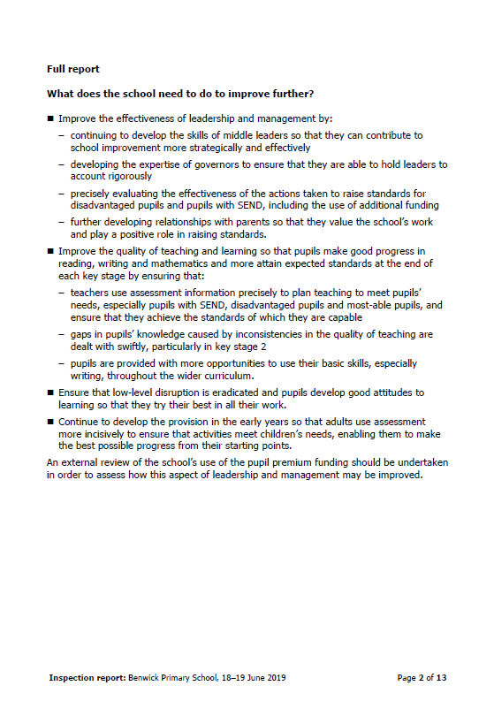
Person specification
Qualifications, Skills and Experience | Essential or desirable | Identified by:
National Professional Qualification for Headshop (NPQH) – or definite placement on appropriate course | Desirable | Application form
Recognised Teaching Qualification | Essential | Application form
First level degree or equivalent | Essential | Application form
Proven leadership skills | Essential | Reference / Interview
Proven skills in strategic management | Essential | Reference / Interview
Excellent communication skills | Essential | Reference / Interview
Appropriate experience as a Head Teacher, Deputy Head Teacher or Senior Leader within a ‘Good’ school in the last 2 years | Essential | Reference

Personal attributes | Essential or desirable | Identified by:
Has a passion for education and developing the whole child | Essential | Reference / Interview
Is dynamic, creative and innovative | Essential | Reference
Will build on the strengths and achievements of the school | Essential | Interview
Is well-organised and manages time effectively | Essential | Reference / Interview
Is able to think and act strategically | Essential | Interview
Is a dynamic teacher able to involve all year groups | Essential | Reference / Interview
Has the desire to foster relationships with other linked schools and the wider community | Desirable | Interview

Knowledge and Understanding | Essential or desirable | Identified by:
Is committed to developing a staff who have the necessary skills and knowledge to promote equality, respect diversity and challenged stereotypes to promote the rights of young people | Essential | Reference / Interview
Recognises the role parents, carers and families play in helping children succeed and thrive, through being healthy, staying safe, enjoying and achieving, making positive contributions and achieving economic well-being | Essential | Interview
Has a commitment to working with the Governing Body to develop a unifying school vision, embracing excellence, high standards and inclusion | Essential | Interview
Has a desire to develop flexible and effective approaches to learning and teaching to attain and maintain higher standards | Essential | Interview
If fully committed to the personal development of all members of staff including a clear Performance Management process | Essential | Interview
Has a commitment to develop leadership and management skills of all staff to achieve strength in depth in the organisation of the school | Essential | Interview
Is able to develop school self-evaluation to ensure we are working effectively towards the academic, spiritual, moral, emotional and cultural development of all its pupils | Essential | Interview

The Governing Body and the Local Authorities are committed to safeguarding and promoting the welfare of children and young persons. The successful candidate will be required to undergo an Enhanced Disclosure from the Disclosure and Barring Services.

