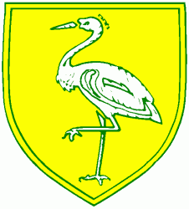
Benwick Primary School
High Street, Benwick, March, Cambs. PE15 0XA

Telephone: 01354 677266 email: office@benwick.cambs.sch.uk

Headteacher: Mrs. J. North, BEd Hons, NPQH www.benwick.cambs.sch.uk
16-May-19

Midday Supervisor
Start date: Mid June or September 2019

Benwick Primary School is a small welcoming and vibrant village school in the heart of the Fens. We are looking for a Midday Supervisor to join our current team.

We are seeking someone who has experience of managing children, whether in a professional capacity or as a Mum.

If you are:
- Keen to provide guidance and support to our children
- Can set up and lead outdoor/indoor activities with the children
- Can supervise the children eating either a packed lunch or hot dinner, ensuring they are eating enough each day
- Have good behaviour management skills

Then we would love to hear from you.

To request an application pack please contact our secretary, Mrs Spencer by email office@benwick.cambs.sch.uk or telephone 01354 677266. Details can also be found on our website at www.benwick.cambs.sch.uk.

We are committed to safeguarding and promoting the welfare of children, and expect all staff and volunteers to share this commitment. An enhanced DBS check will be sought from the successful candidate along with two professional references.

Closing Date: 7th June 2019; Interviews 12th June 2019

