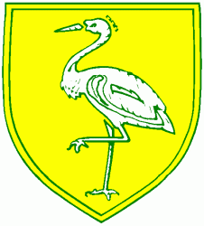
Benwick Primary School
High Street, Benwick, March, Cambs. PE15 0XA

Telephone: 01354 677266 email: office@benwick.cambs.sch.uk

Headteacher: Mrs. Clare Talbot www.benwick.cambs.sch.uk
23-Jan-20

Dear Parents/Carers,

Making it quicker and easier to apply for free school meals
As part of our work to support families in poverty we have redesigned our online form for families wishing to check their free school meal (FSM) and Pupil Premium eligibility. Significant improvements made to the online application process enable parents/carers (in most cases) to get an instant result of the outcome of their application.
We respectfully ask all schools to promote this to existing families (who have not applied or qualified in the past) and to new families starting in September or indeed at any point during the school year - www.cambridgeshire.gov.uk/freeschoolmeals
It is not necessary for parents of children who currently receive FSM to reapply as this entitlement is protected until the end of March 2022. However, applications do need to be made for younger siblings who are starting school.
With recent changes to the benefit system due to the phased roll-out of Universal Credit, families may not necessarily realise that they qualify. Therefore, this is an optimum time for promotion.
The form is quick and simple to complete. Once an application has been submitted for a child, if the family do not qualify at that point, we will continue to check for future entitlement throughout that child’s school life, informing parents if they become eligible. It is vital, therefore, that schools/families inform us of any changes to their name or address.
Families can access the online application at www.cambridgeshire.gov.uk/freeschoolmeals
The Education Welfare Benefits Team are happy to answer any queries and can be contacted on 01223 703200 or ewb.fsm@cambridgeshire.gov.uk

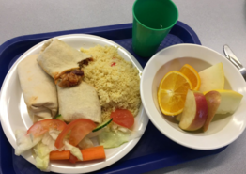
There are also ‘Count Me In’ Forms in the school lobby area in clear plastic wallet

