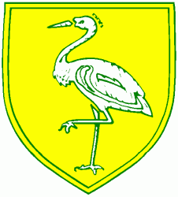
Benwick Primary School
High Street, Benwick, March, Cambs. PE15 0XA

Telephone: 01354 677266 email: office@benwick.cambs.sch.uk

Headteacher: Mrs. J. North, BEd Hons, NPQH www.benwickprimaryschool.ik.org
28-Apr-19

Link Up Robins Class – Summer Term 2018-19

A very warm welcome back to our last term in Reception! I can’t believe how quickly the year is going; before we know it we will be finishing for the summer. I am really excited to be back with the children after my maternity leave and look forward to getting to know our families more as the term progresses. My door is always open so please do pop in to say hello or ask any questions you may have; the Reception year revolves around home and school working together to give the children a solid base for their future education, and so I welcome any input you may have.

We have got straight back into our learning in Robins and have already enthusiastically started our new topic, Dinosaurs. Last week, we started to find out when the dinosaurs lived, the names and features of some different dinosaurs and also about dinosaur fossils. We had an absolutely fantastic Forest School session on Friday where the children worked amazingly well in small groups to create their own dinosaur worlds using the natural materials they could find; it was lots of fun! A few photos below…
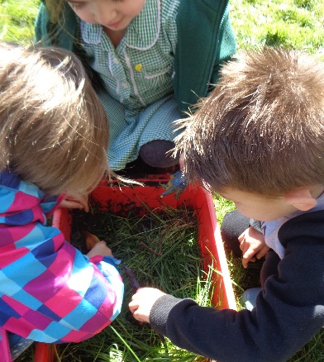
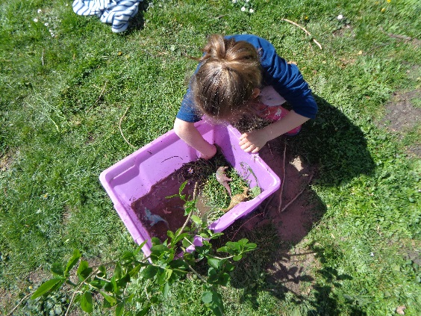
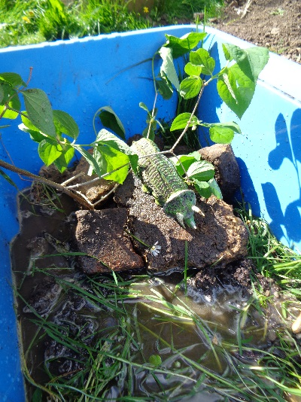
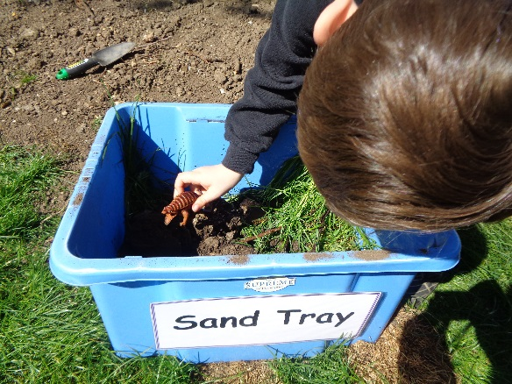

As the term progresses we will be reading and enjoying many texts linked to the dinosaurs, and will be focusing in particular on the lovely ‘Harry and the Bucketful of Dinosaurs’ stories. The children are all making wonderful progress with their reading and writing, and over the half-term we will be working to extend these skills by embedding features like finger spaces, capital letters and full stops in their written sentences. We are continuing to work through the Read Write Inc phonics programme, where the children get to practise their word and sentence reading and writing skills every day. If you would like to know more about how we teach your children to read and write, please don’t hesitate to ask.

In Maths we will continue to build on the children’s numeracy skills, including areas such as number ordering, counting forwards and backwards, solving addition and subtraction problems, and halving and doubling. We will also work on our understanding of shape, space and measures through lots of fun and practical dinosaur themed activities.

PE will take place on a Tuesday afternoon, and we will also have a ‘Physical Development’ session on a Wednesday, which will focus less on sports and more on developing the children’s gross and fine motor skills. All children need to have a named PE kit in school with an appropriate change of footwear. Although we will not always need to get changed for the Wednesday session, dependent on its content, it is a good idea to keep their kit in school all week and take it home for a wash on a Friday; now we are moving towards summer there may be additional sports activities during the week. We will also continue with our Forest School sessions on a Friday morning, so please make sure your child comes dressed in their Forest School gear with their school uniform in a named bag to change into. A spare carrier bag for dirty wellies is also very helpful.

I am very pleased with the progress the children have made with their reading since the beginning of the year and would like to thank Miss Angell for doing such a super job in my absence – I would also like to thank you for your ongoing support from home. It is really important that the children spend ten to fifteen minutes each day reading with a grown-up at home, and we really appreciate comments made in the children’s reading record books to help us know how they are getting on. Books will be changed on a Monday, Wednesday and Friday if you have written that the book has been finished, and key words will be checked each week when the children read to a grown-up in school.

I’d like to take this opportunity to mention our ‘Wow!’ cards, which are a valuable tool for communicating your child’s successes at home to us here at school. Although we spend lots of time making observations of your child’s learning and of course looking at the work they produce, it really helps our judgements of ‘where they are at’ if we can have information from home as well. If you’d like a reminder of the kinds of things we are looking for, please ask.

Finally, a quick plea! We are once again running low on materials for ‘junk modelling’, so if you can keep hold of any dry recycling (cereal boxes, kitchen roll tubes, plastic bottles etc) and send it in with your child it would be very much appreciated.

Here’s to a successful and hopefully sunny term ahead!

Kind regards,
Mrs Johnson

