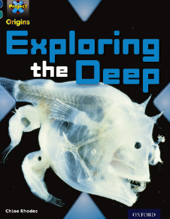
Exploring the Deep – Week 9
p.1-7
‘Exploring the Deep’ ties in with our topic of Oceans. Over the next few weeks, this will be our focus book. You will be expected to read the designated pages and answer the accompanying questions.
Q1
Use the glossary at the back of the book to define each of the words written in bold.

Q 2
Name the 5 main oceans of the world.

Q 3
What percentage of the earth is water and land?

Q 4
How many zones are there? What are they?
Q 5
What is the continental shelf?
Q 6
What is the continental slope?

Q7
What are seamounts?

Q8
Describe the deep ocean floor

Q9
Choose one of the following and give 4 facts about it.
* parrot fish
* box jellyfish
* brain coral

