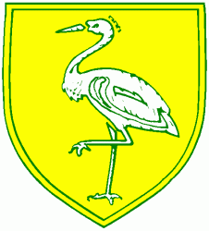
Benwick Primary School
High Street, Benwick, March, Cambs. PE15 0XA

Telephone: 01354 677266 email: office@benwick.cambs.sch.uk

Headteacher: Mrs. J. North, BEd Hons, NPQH www.benwick.cambs.sch.uk

19-Jun-15

BENWICK SCHOOL - WALK TO SCHOOL WEEK - 16th - 20th MAY 2016

In March 2016 we asked the children how they had come to school. 48 children said the had come to school that day in a car - this is 47% of our school. Only 14 children said they would prefer to come in the car and 31 said they would like to cycle to school. With this in mind we are joining in with this national event every day of next week.

Children can come to school on bicycles, scooters or any other mode of transport as long as you try to leave your car at home. If you really can’t come without the car then perhaps you could park a little further away and walk the last bit or car share with another family. Bikes and scooters may be left in the bicycle or scooter racks. Please remember that if your child cycles to school they will need to wear a cycle helmet.

We will be asking the children each day to fill in a class grid so we can find out which class was the most Eco friendly!

For more information please have a look at the website:

http://www.livingstreets.org.uk/what-we-do/projects/walk-to-school-week

Let’s hope the sun shines!

Thank you for your continued support for our work.

