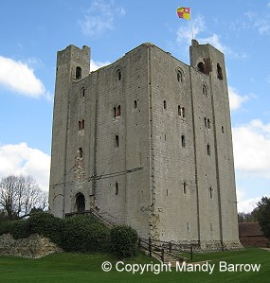

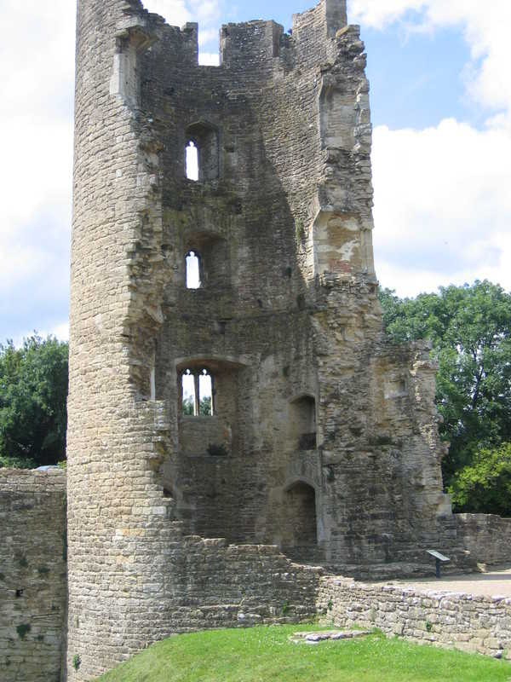

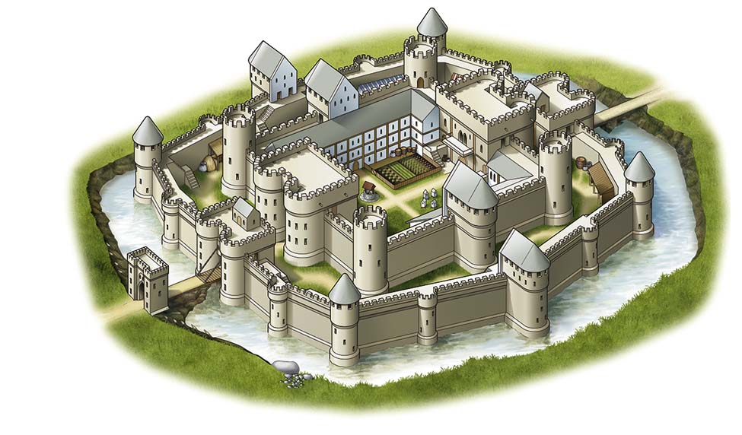
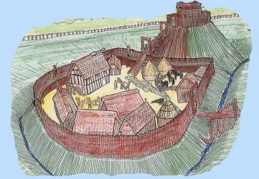
First | Later
1066 | 1200
Motte and Bailey Castles | Stone Castles
After that |  | Now
1239 - 1307 |  | 2021
Concentric Castles |  | Ruins

