The Stinky Cheese man and Other Fairly Stupid Tales
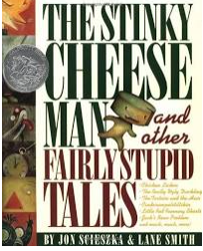

Author: Jon Scieszka
Illustrator: Lane Smith

Watch at (for example) https://www.youtube.com/watch?v=vB07RfntTvw&t=18s

In this humorous book, the author takes well-known traditional tales and changes them to make new versions!

Something to think about:
- Count the traditional tales that are used in the book – there should be around 12!
- Think about how the makers of the book have changed the stories. For example, they have might have mixed up one story with another one or given the story a sad ending rather than a happy one.
Something to do:
- Choose one of the traditional tales used in the book that you know well. Write down two versions of the story – the original version, then the changed version. Just write a few sentences to summarize the main points – you don’t need to retell the whole story in detail!
- Create a collage using scraps of newspaper and other bits in the style of Lane Smith, the illustrator.

The Tunnel
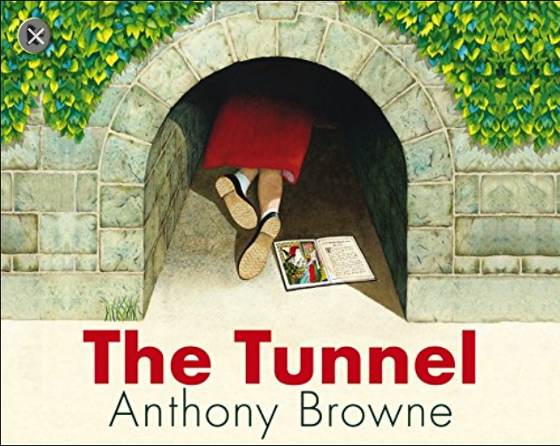

Author and illustrator: Anthony Browne

Watch at (for example)
https://www.youtube.com/watch?v=ZGNRdhNbvbQ

Like most siblings, Rose and her brother Jack are always arguing! One day they crawl through a tunnel and discover a mysterious forest…

Something to think about:
- How does Anthony Browne make use of fairy tales?
- After reading, what questions do you still have about this story?
Something to do:
- What could the title of the book have been instead? Draw an alternative cover.
- Once home, Jack and Rose phone or email their friends to explain what has happened. What might they say or write?

