Reception Phonics Helper - Week 1
These are the focus sounds Year R are looking at in phonics this week. You can support your child by:
- Asking them to recall the sounds on the flashcards below.
- Write the letters – practice forming the letters correctly.
- Fred Talk the Word – sound the word out for your child and ask them to blend the sounds.
- Build the words – children could use magnetic fridge letters, or pieces of paper/Lego with the sounds written on to build the words.
- Read the words – Can they spot them in books? Can they go on a word hunt and find them hidden around the house?
- Write the words – on paper, in the mud with a stick, paint them, or make them out of play dough.
- Sound Buttons - Ask your child to add sound buttons to words they or you have written – a dot for a sound made up of a single letter and a dash for sounds made up of two or more letters. They could also use found objects e.g. conkers and sticks.

Sounds we already know
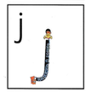  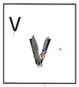  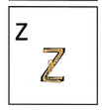  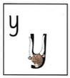  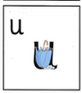  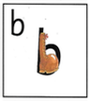  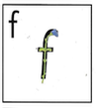  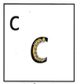  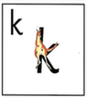  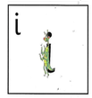  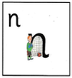  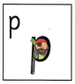  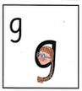  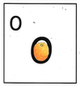  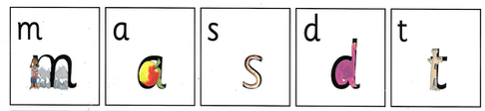  \ |  |  |  | 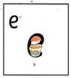  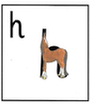  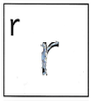  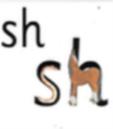  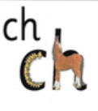  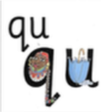  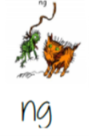  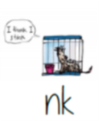
This week’s phonics focus sounds
Fred Talk the Word
l-i-p = lip  l-e-g = leg | h-e-n = hen  h-a-t = hat | sh-o-p – shop  f-i-sh - fish | r-e-d = red  r-a-t = rat | j-e-t = jet  j-a-m = jam | v-e-t = vet  v-a-n = van
Build, Read and Write
lip, leg, let, log | hen, hit, hat, had, | shop, ship, shed, fish | red, run, rat, rip | jet, job, jog, jam | van, vet
Sound Buttons
log | hat | shed | run | jog | vet

