Maths Homework Grid (Y1)

Learn 5 addition facts, play a maths game and choose one other thing to work on each day. The video links are there to help you understand the activities.

Addition facts  Copy the caterpillar below. Use 2 different coloured pens (1 for each player) and 2 dice. Roll the 2 dice, add the numbers and write the total on one of the circles  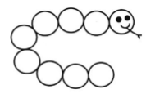  A number can only be written once. The numbers must be in order on the circles. If there is no space for your number, you miss a turn. When the caterpillar is full, count how many numbers are written in each colour to find out who is the winner.  https://www.topmarks.co.uk/maths-games/hit-the-button | Maths Games  Choose a maths game to play each day.  Have a go at inventing your own maths game.  Link to a blog on maths games:  https://matr.org/blog/fun-maths-games-activities-for-kids/
Tic Tac Teen  Download and play Tic Tac Teen from https://www.teacherspayteachers.com/Prod uct/Tic-Tac-Teen-Teen-NumberRecognition-Game-freebie-993510  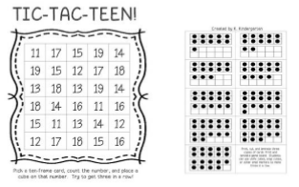  How can you work out the number on the card quickly? Do you have to count all of the dots? | Addition  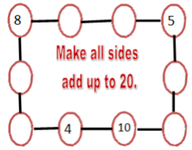  Can you create your own?  https://www.topmarks.co.uk/maths-games/5-7-years/addition-and-subtraction
Number bonds to 10  Roll a dice. What number do you need to add to it to make 10? Repeat 5 times.  Roll a dice. What number do you need to add to it to make 20? Repeat 5 times.  What do you notice?  Roll two dice. Can you add the numbers together? If you roll two dice, how many possible ways of making 10 are there by adding the two numbers together?  https://ttrockstars.com/ (Numbots) | True or false  Decide if these statements are correct and try to explain your reasoning using examples.  • If I add 1 more to a number, the tens digit ALWAYS stays the same.  • If I find 1 less than a number, the tens digit ALWAYS stays the same.  • 1 more than 14 is 24.
Months of the year  The months of the year have got in a muddle (see below). Can you write them in the correct order?  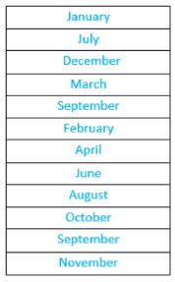  Can you write your birthday next to the correct month? Try to add at least 6 more important celebrations or events next to the correct month. Can you draw a sunshine next to a really hot month? Can you draw a snowman next to a really cold month?  https://www.topmarks.co.uk/maths-games/5-7-years/data-handling | Growing related calculations  Start with a calculation you already know the answer to e.g. one of the pairs that make 10 like 6 + 4 = 10.  Now experiment with the numbers to create other number facts without having to calculate from scratch e.g. you could add 1 to one of these numbers and the answer would go up by 1 too. 7+4=11, 6+5=11.  You could add 10 to one of the numbers and the answer would go up by 10 too. 16+4=20, 6+14=20.  You could swap the order around to make 4+6=10 and repeat all the steps above.  Can you think of a related subtraction fact? 10-6=4, 10-4=6.  If you take away an extra 1 what will happen to the answer? 10-7=3, 10-5=5.  Keep experimenting going back to the first calculation each time.  How many related calculations can you make?
Time to o’clock and half past  Use a paper plate or cut out a circle of card. Ask an adult to help you find the middle. Draw lines to divide the circle into quarters. Label the top 12, the bottom 6 and the sides 3 and 9 so that you have started to make a clock. Put in the rest of the numbers. Make the hands and attach just the shortest hand. If you don’t have a split pin to attach a hand, you could use a small piece of spaghetti with blu-tak on either end. This is the hour hand.  Where will the hour hand need to be for 2 o’clock, for half past 2, 4 o’clock, half past 5, 6 o’clock, half past 7, 9 o’clock? Can you tell the time using just this hand? Explain this to someone.  Add a minute hand where does this go for o’clock and half past?  https://www.topmarks.co.uk/Search.aspx?q=telling+time  https://www.everyschool.co.uk/maths-key-stage-1-tell-the-time.html | Read and write numbers from 1-20 in numbers and in words  Roll a dice. Write the number on the dice in words.  Create 20 playing cards/papers. Write the words 1-10 and the numbers 1-10 on the pieces of card/paper.  Play a game with your parent/friend. Mix up all the cards and turn all the cards upside down. Turn two pieces of card over at a time. If they are the same number keep them.  The winner is the person with the most cards at the end of the game.  You could also use your cards to play SNAP.
2D shapes  Which shapes can you see in this picture? Can you draw your own picture of an animal using 2D shapes? Can you label them?  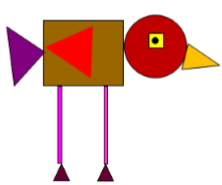  https://www.bbc.co.uk/bitesize/topics/zjv39j6 | Mass/weight  Fill the sink up with water. Find lots of different containers. Put the containers into order by predicted capacity.  How will you check that you are correct? You could use a small cup and use it to fill each container in turn and count how many it takes for each one.  You could find a really big container then pour water from each container into it. If you make a mark on it for each one, you will be able to see the order at the end.  You could investigate further by guessing how many of container A will fit into container B and then checking.  https://www.everyschool.co.uk/maths-key-stage-1-measurement.html
Money  If I have 10p in my purse. What coins could I have in the purse?  Can you find all of the possibilities?  What is I have £1 in my purse, what coins could I have now?  Can you find all the possibilities?  https://www.topmarks.co.uk/maths-games/7-11-years/money | Measures  Get 5 of your teddies or toys. Can you order the teddies from tallest to shortest?  Can you measure the toys with a ruler?  How else could you measure the teddies/toys? Which one is the heaviest? Can you order them form heaviest to lightest?  Using art materials, can you make 3 creatures all different lengths. Which one is the longest/ shortest?  Can you make them all the same length? Do you need to add to some of the creatures to make them the same length?  https://www.everyschool.co.uk/maths-key-stage-1-measurement.html

