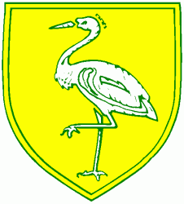
Benwick Primary School
High Street, Benwick, March, Cambs. PE15 0XA

Telephone: 01354 677266 email: office@benwick.cambs.sch.uk

Headteacher: Mrs. Clare Talbot www.benwick.cambs.sch.uk
22-Jan-20

Dear Parents / Carers,

Message from Miss Baker. She would like you to know that they arrived safely and have settled and mixed in well with Townley School.

They have eaten a lovely lunch of spaghetti with meatballs served with garlic bread followed by jam sponge.

They are now outside enjoying the orienteering activity.

Kind Regards

Mrs Brenda Baker

