Maths Homework Grid (EYFS/YR1)

Counting and patterns  Buy some skittles. Can you count how many there are of each colour?  Adults make sure they touch and move each skittle as they count. Can they say how many there are now? Rearrange the same skittles so they just take up more space and ask how many there are again? Do they realise the number is still the same?  Use 2 or 3 colours to make a continuous repeating pattern all around the edge of a plate. Now pour some warm water into the middle and watch the patterns swirl.  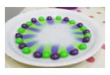  Can you write a label to show the number? | Patterns  Make repeating patterns with toys, food or natural objects found outside. Can you continue a pattern started by your parent or copy their pattern somewhere else? Can you create the same pattern with different objects?  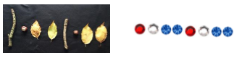  You could even invent a code to represent your pattern.  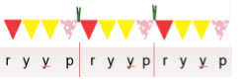
Numbers  Look in your food cupboard and find objects you can count like pasta, cereal or if you are lucky, sweets.  Take a dessertspoon of each (the numbers need to all be below 20 so adjust the spoon size if necessary).  Ask the children questions such as, do you think there are more pieces of pasta and cereal? How do you know? Can you prove it? (they could match them up in pairs to check/prove it)  Try comparing two more sets but this time ask which has got less. Out of all of the sets which has got the most?/ the least?  How many have you got of each object? | Numbers to 10  Can you make a model with just 2 colours of lego (or any other construction toy) that uses exactly 10 bricks? How many of each colour did you use? Can you think of a way to record this? E.g. child may draw 4 blobs of red and 6 blobs of yellow or you could write headings and they could record numbers 4 and 6.  Can you swap one of your bricks for the other colour and record the new combination? Keep exploring this to see how many different ways you can make 10. You could do a similar activity with other numbers up to 10.
Length  Find a stick and decorate it with paint, glitter, curling ribbon, fimo, card shapes to create a magic wand. Can you find 5 things that are longer than your wand and 5 things that are shorter and draw them? Make sure you line up the ends carefully to check. Go back to your longest object. Using your magic wand, can you now measure how many magic wands long it is. How many magic wands tall are you? | Weight  Make a spring scale like this one.  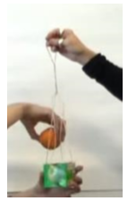  For instructions go to https://nrich.maths.org/13361  Have fun weighing a few different items and seeing how far they make the elastic stretch. Which item was the heaviest? Which item was the lightest? Choose another item and this time predict whether it will be heavier or lighter than the others before you weigh it.
Daily activities  Watch this story about Frog and Toad where toad makes a list of all the things he has to do that day  https://www.youtube.com/watch?v=tqQiBsAuDZ8  Make a list of all the things you are going to do tomorrow. Cross them off as you do them. | Counting songs  Learn a new counting song or practise an old favourite.  You can listen and watch some classics here https://www.bbc.co.uk/programmes/p065z8 z4  Maybe you could bake some currant buns and act out that song too!

