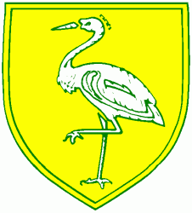
Benwick Primary School
High Street, Benwick, March, Cambs. PE15 0XA

Telephone: 01354 677266 email: office@benwick.cambs.sch.uk

Headteacher: Mrs. J. North, BEd Hons, NPQH www.benwick.cambs.sch.uk
16-Dec-19

Dear Parents/Carers,

We are now in a position to inform you about teaching for Robin’s class from January 2020 for the Spring Term.
We regret that we weren’t able to give you details before the weekend but we now have a firm plan which will provide excellent provision in the New Year.
The teaching team will be as follows:
Mrs Mary Palmer on Tuesdays, Thursdays and Fridays.
Miss Lauren Stone on Mondays and Wednesdays.

We have worked very hard to set up the best possible arrangements for the class.

Once again, it has been lovely working with you and your children.

Yours faithfully,

Mr. R. Lloyd and Mrs C Carlisle

