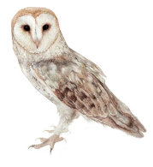
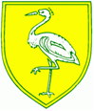
Owls Class Spring 2 Topic 2021 – Where on Earth?

English:  Winter’s Child – Angel McAllister  Tin Forest – Helen Ward & Wayne Anderson  Poetry week 15.3.21 | Maths:  Fractions  Finding and recognising ½, ¼, 1/3,  Unit and non-Unit Fractions  Equivalent fractions  Counting in frcations  Addition and subtraction (recap skills) | Science:  States of matter  Exploring and comparing solids, liquids and gases  Observe how materials change state when they are heated or cooled  Identify evaporation and condensation and what chnges the rate of both  Science day 12.3.21
PSHE:  Citizenship and working together  Recognising strengths and worth  Identify skills to develop  Learn a new class skill  Understand and practise communication skills  Develop effective group work skills, problem solving and decision making. | Music: The Dragon song  Playing a glockenspiel stage 1 | RE:  The Easter Story
PE:  Archery  The Daily Mile | Art: Pointillism  Demonstate and experience different grades of pencil and other implements to draw intricate patterns  Develop pointellism skills and learn about the artist Geogre Seurat  Use pointillism skills to draw a detailed self portrait | Geography:  What is the water cycle?  How does it work?  What affects the water cycle?  What are the countiries and capital cities of the UK?  Name physical and human characteristics in different regions.

