LO: to describe a character
LO: to have an opinion and to explain reason for an opinion
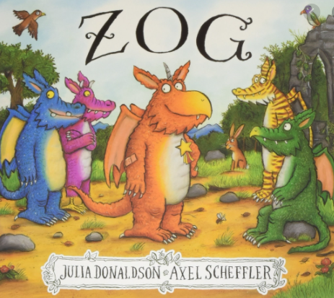
Word bank
dragon because
wings
horn
tail
claws
gold star
blue
purple
pink
orange
striped
scales

Look carefully at the front cover of this book. What is similar about the dragons? What is different about the dragons? Which dragon is your favourite? Why? Choose your favourite dragon and describe it.
___________________________________________________________________________________________________________________________________________________________________________________________________________________________________________________________________________________________________________________________________________________________________________________________________________________________________________________________________

