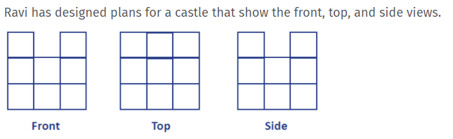

This is a plan on paper for a castle. Can you make this castle? Do you have bricks or Lego at home to use? (or uses boxes, items from the kitchen)
How many cubes would you need to make this castle?
Next….
Can you make your own castle, using items you have in the house and then draw a plan for it, showing the front, the top and the side?

