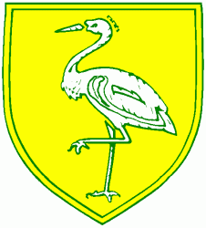**Benwick Primary School**

**High Street, Benwick, March, Cambs. PE15 0XA**

**Telephone: 01354 677266 email:** [**office@benwick.cambs.sch.uk**](mailto:office@benwick.cambs.sch.uk)

**Chair of Governors: Darren Gore** [**www.benwick.cambs.sch.uk**](http://www.benwick.cambs.sch.uk)

29/10/2019

Dear Parents,

As you may be aware on 15th October 2019 a panel of 3 governors along with the schools local authority advisor conducted a recruitment day for the Head teachers position.

We were very lucky to have had 2 excellent candidates on the day, who both showed off their experience, knowledge and passion, making the panels decision very difficult.

I am both pleased and excited to announce that starting in January Mrs Clare Talbot will be the schools new Head teacher. Clare has an extensive teaching career as well as 10 years experience in leadership roles both within medium and small sized schools. Clare is currently head teacher of an Ofsted ‘Good’ school in hertfordshire, she has evidenced to the panel the improvements she has made in that school which are backed up by recent local authority inspections showing ‘Outstanding’ features. Clare showed the panel her passion and enthusiam and shared her aims and expectations in how she will lead Benwick Primary School from its current Ofsted grading to ‘Good’ and beyond.

Although a tough decision on the day, the governors were delighted at having the choice of two excellent candidates but remain satisfied the correct person was appointed. The governing body itself has gone through many changes recently and are more committed than ever to support the school in making swift improvements and know that the recruitment of the right head teacher is a vital part of that process.

You may see Mrs Talbot around the school in the coming weeks as she will be spending a few days with us to ensure the best possible handover from the current interim heads.

Mrs Talbot will start at the beginning of the Spring term in January and I hope you will support the staff and governors in making her feel very welcome.

Kind regards



Darren Gore

Chair of Governors