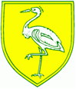
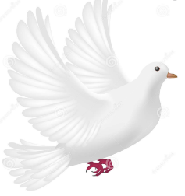Doves Class Autumn Topic 2020 – What a Wonderful World

English:  Here we are – Oliver Jeffers (Whole school book)  The Tin Forest- Helen Ward Wayne Anderson  The Jolly PostMan Jannet and Allan Alhberg | Maths:  Number: Place value  Number: addition and subraction  Measurement: Money | Science:  Humans including animals  Living things and their habitats  Revision - materials
PSHE & RE:  What makes a Christian person special? (T1)  What is Christmas & Advent? (T2)  Beginning and relonging: rules, building realtionship and new situations | Art & Design:  Van Gogh as an artist  Self Portraits  Sketching, drawing & painting | Music:  Hey You!  Listening, appraising  Playing instruments
PE:  Athletics (taught by class teacher)  Games (taught by sports coach) | Computing:  Portraits using laptop/ipad packages | Geog/History:  Famous person in history Neil Armstrong  Name and locate continents & oceans  Name and locate & identify characteristics of the UK and surrounding areas
Enrichment:
Anti – Bullying week (16^{th –} 20th November)
Christmas Design & Technology project- theme to be decided

