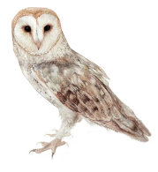
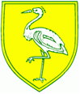
Owls Class Autumn Topic 2020 – What a Wonderful World

English:  Here we are – Oliver Jeffers (Whole school book)  Flotsam – David Weisner  The Wonder Garden – Jenny Broom  Pebble in my Pocket – Meredith Hooper  The Streets Beneath my Feet – Charlotte Guillian | Maths:  Number & place value  Addition & subtraction  Multiplication & division  Fractions including decimals  Measurement  Geometry- position & direction, shape  Statistics | Science:  Humans including animals  Living things and their habitats  Rocks  Materials (revision)  Forces  States of matter  Light (revision)
PSHE & RE:  Beginning and relonging: rules, building relationship and new situations  Why do Christians pray and worship? | Art & Design:  Self Portraits- pencil skills, painting skills  Sketching, drawing & painting  Van Gogh – the artist and his work | Music:  Mama mia - As well as learning to play, improvise and compose with the well known song Mamma Mia, children will listen and appraise more ABBA hits.
PE:  Athletics (taught by class teacher)  Games (taught by sports coach) | Computing:  Online safety  Coding | Geog/History:  Chronology of space exploration  UK, Europe and the Americas  Map work  Human and physical geography
Enrichment:
Anti – Bullying week (16^{th – 20th} November)
Christmas Design & Technology project- theme to be decided

